**Name: Heet Patel**

**Roll number: 24BPEO74**

**Branch: Petroleum**

**Semester: 2nd**

**Division: 2**

**Batch: P3**

**Lab: 1**

1.Add two numbers.

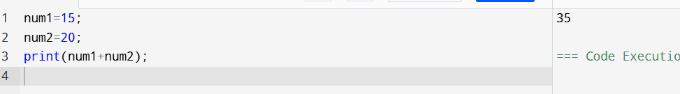

2.Subtract two numbers.

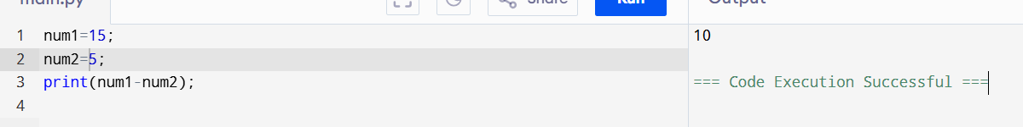

3.Multiply two numbers.

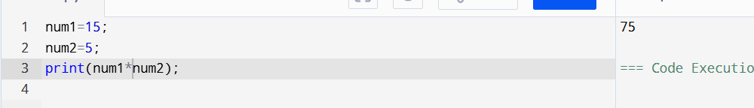

4.Divide two numbers.

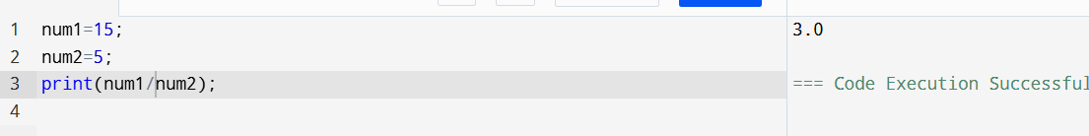

5.Add, multiply, subtract and divide two numbers.

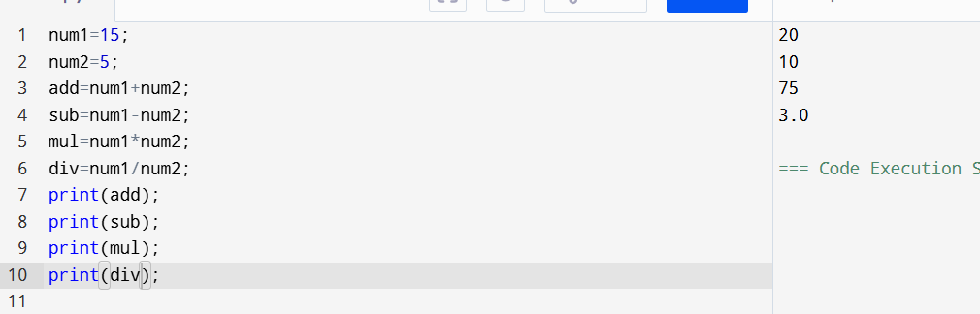

6. Convert hours into minutes**.**

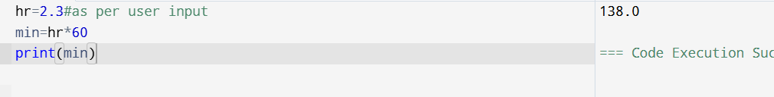

7.Convert minutes into hours

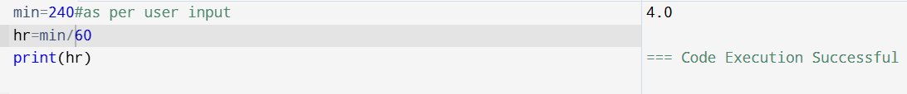

8.Convert dollars into Rs. Where 1$=48 RS.

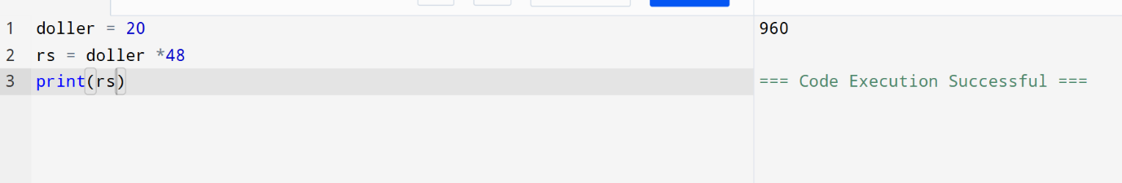

9. Convert Rs. into dollars where 1$= 48RS.

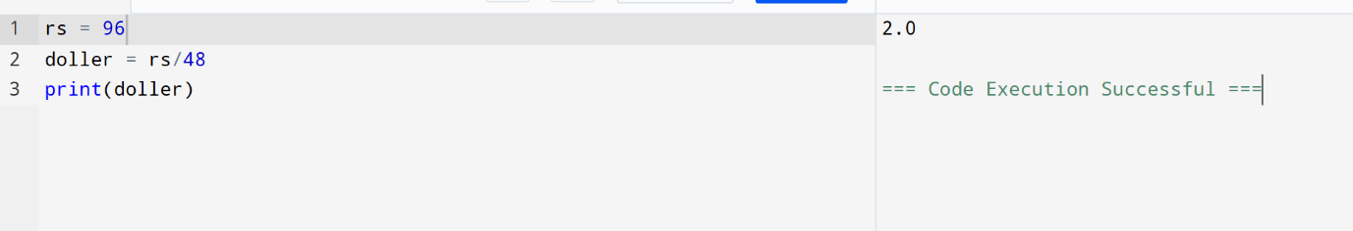

10. Convert dollars into pound where 1$=48 RS. And 1 pond=70 RS

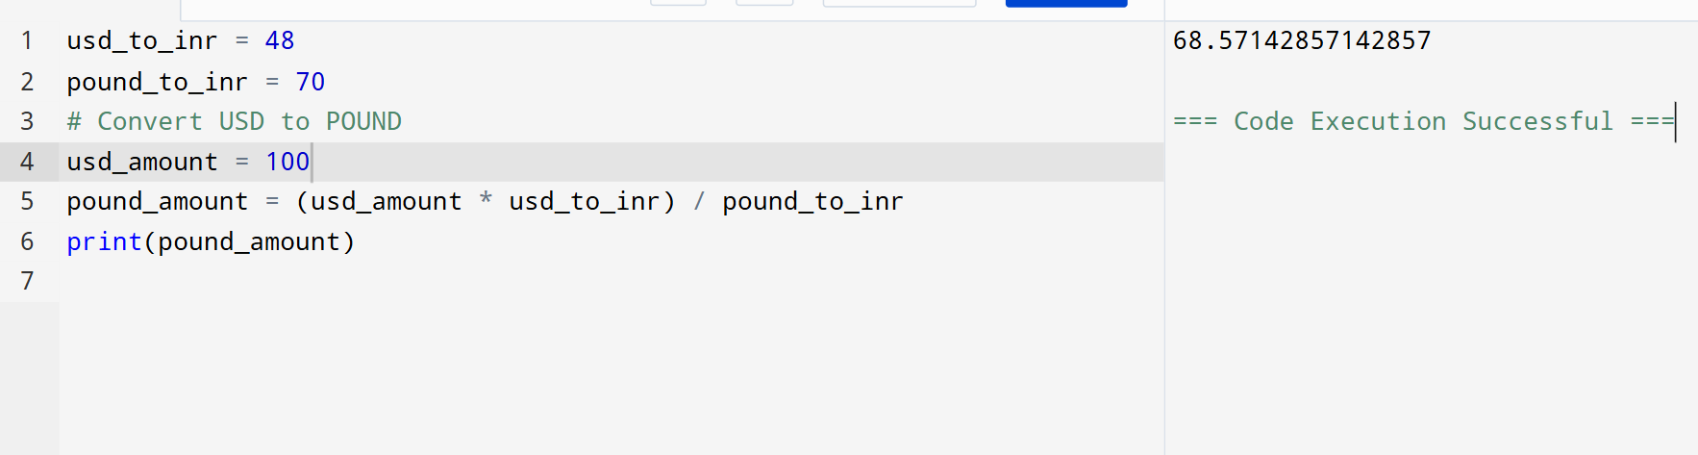

11. Convert Gram in to Kg.

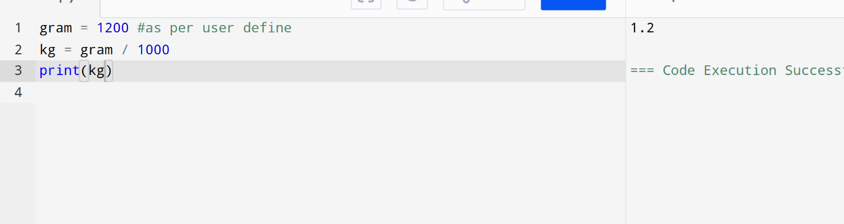

12. Convert kg into Grams.

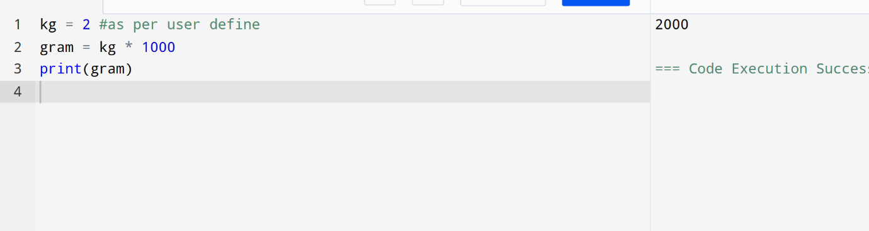

13. Convert byte into KB , MB , GB.

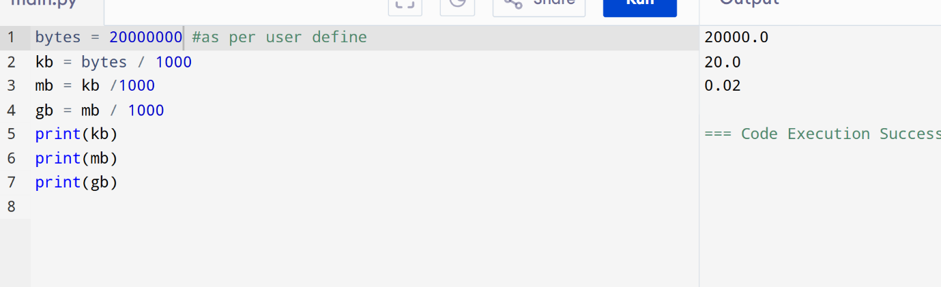

14. Convert Celcius into Fahrenheit.

F = (9/5*C) + 32

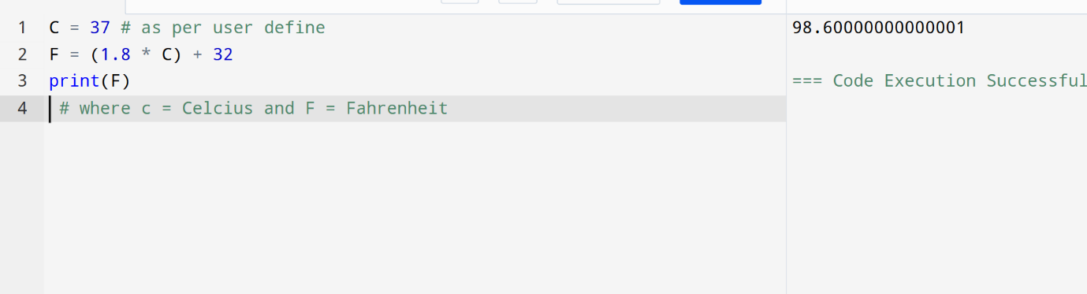

15. Convert Fahrenheit into Celcius.

C = ( 5 / 9 ) * ( F – 32 )

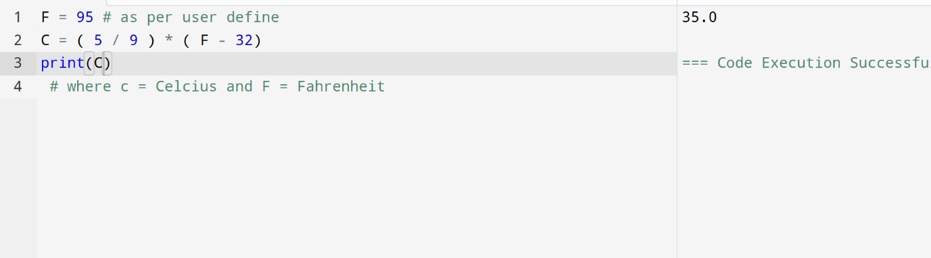

16. Calculate Interest where

I = PNR / 100 .

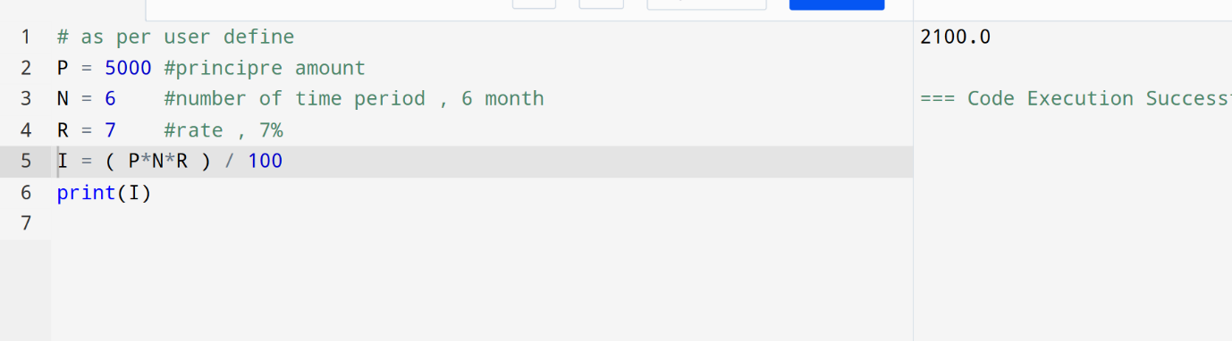

17. Calculate area and perimeter of square .

A = L * L

P = 4 * L

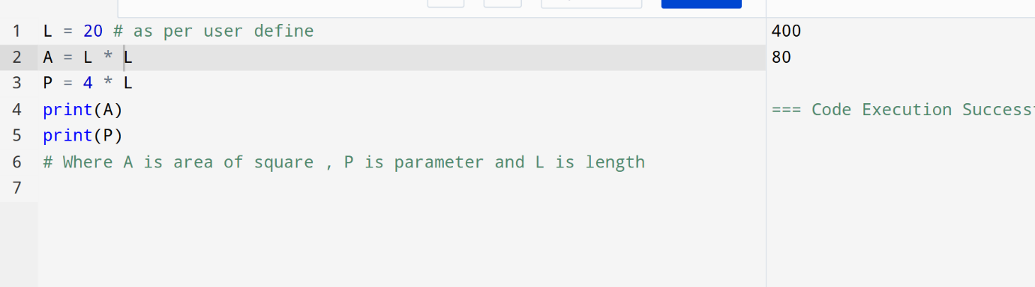

18. Calculate area and perimeter of rectangle.

A = L * B

P = 2 * ( L + B )

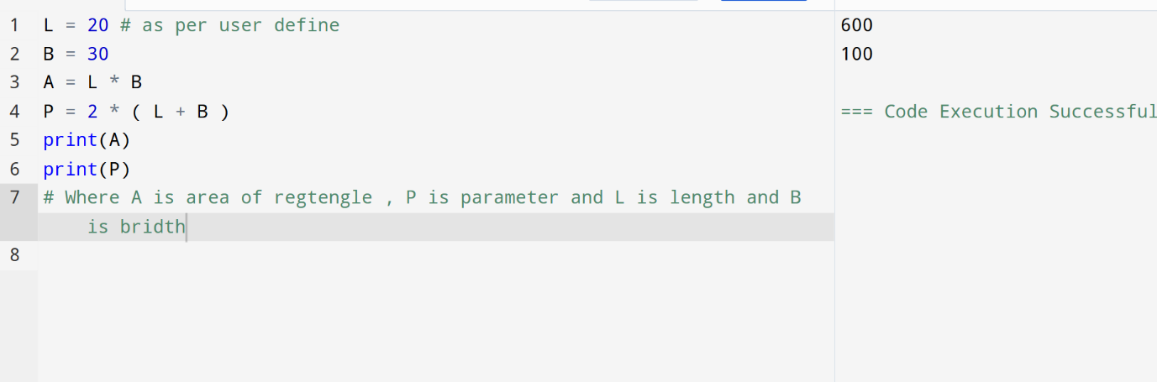

19. Calculate area of circle.

A = (22/7)*R*R

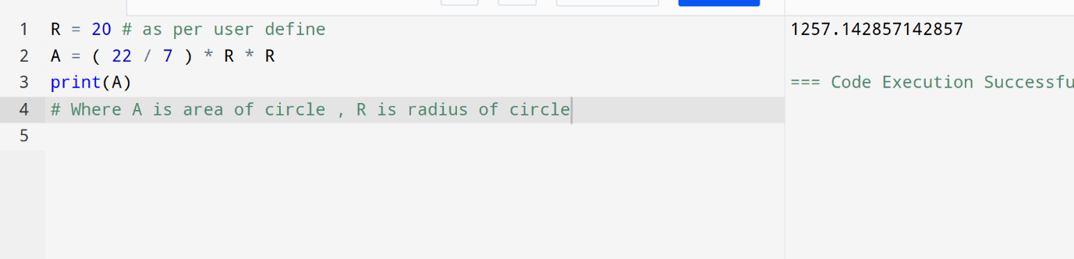

20. Calculate area of triangle.

A = ( H * L ) / 2

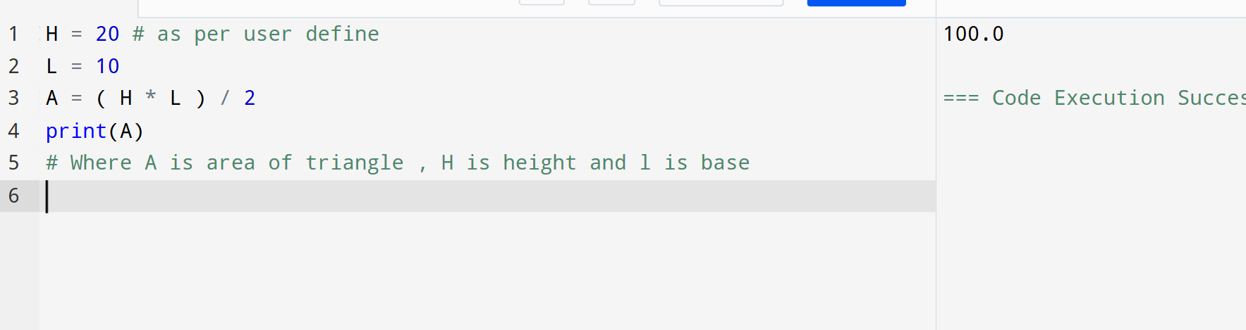

21. Calculate net salary.

Where net salary = gross salary + allowance – deduction

~ allowance are 10% while deduction are 3% of gross salary

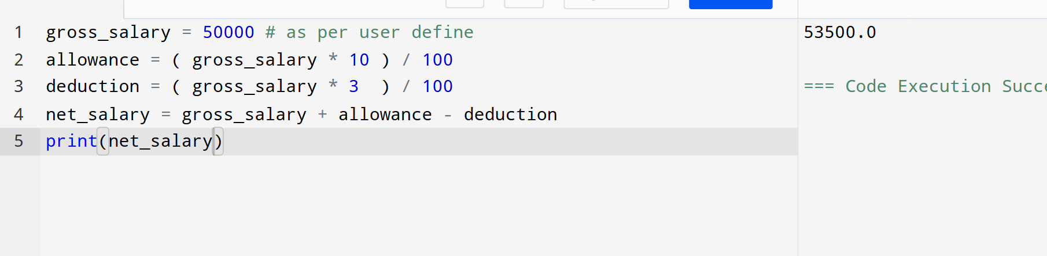

22. Calculate net sales where net sales = gross sales – 10% discount of gross sales.

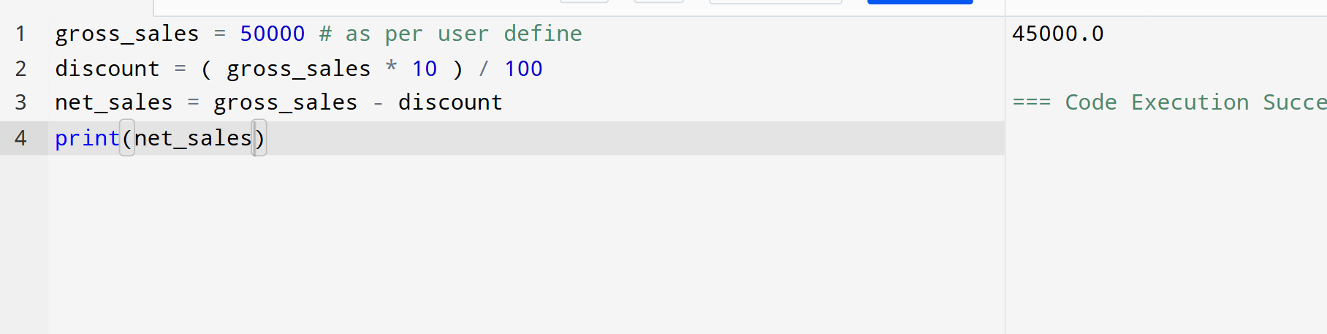

23. Calculate average of three subjects along with their total.

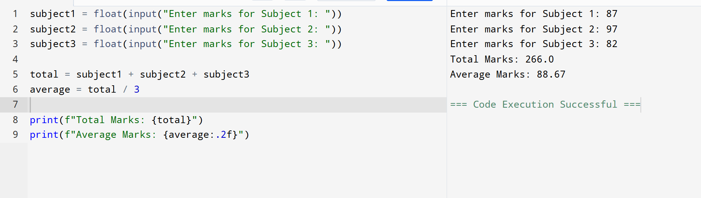

24. Swap two values.

